UniPath Web Application

Business Requirements Document

Project: UniPath Web Application

Author(s): Shazia Khan, Xinhao Huang, George Hidalgo, Praneta Kasbe, Along Zhang, Saahiil Meswaanii, Sanket Bagul

Table of Contents

**1.** **Project Overview - Shazia** 3

**2.** **Document Information – All discuss** 3

2.1 Audience 3

**3.** **Business Opportunity** 3

3.1 Project Overview and Background - Xinhao 3

3.2 Current State Analysis - Saahiil 4

3.3 Future State Objectives - Along 4

3.4 Business Domain Model and Stakeholders - George 4

**4.** **Business Requirements – ALL** 5

4.1 Details of Business Requirements 5

**5.** **Non-Functional Requirements – All discuss** 7

**6.** **External Data Feeds – Praneta** 7

**7.** **Business Risks - George** 8

# **Project Overview - Shazia**

This document describes the business/user requirements for the UniPath web application that will provide the basis for the following project activities:

* Introducing business/user requirements
* Creating test plans and test specifications
* Identifying stakeholders
* Devising solutions to project tasks
* Produce an application that will enable users to have a hassle-free campus life and experience
* Determining when the project is complete
* Assessing the degree to which the project succeeded

# **Document Information – All discuss**

## 2.1 Audience

|  |  |  |
| --- | --- | --- |
| Name | Business Group | Role |
| Subscribed Universities | University | Partner/Supplier |
| Enrolled Students | Daily needs Department | Supplier |
| Local Businesses | Store Department | Supplier |
| Credit Card Vendor | Finance Department | Supplier |
| Advertising sales representative | Advertising Department | Supplier |
| Customers | University and students | Web Application Users |

# **Business Opportunity**

## 3.1 Project Overview and Background - Xinhao

The goal is to create a Web Application that can make students’ campus-life more convenient and easier. Students can sell their used products on the application; the application also allows students to check if there is something interesting to them and to buy. The categories of products will be listed on the application. The students who would like to get the student loan get to check the loan companies' information provided on the application. The application will also provide a map of campus for those students who are new to the university to get familiar with buildings around campus quickly.

## 3.2 Current State Analysis - Saahiil

Transitioning into collegiate life is an important experience of a student’s life. Making purchases of used products online on sites like craigslist, eBay feels unsecure, and many feel uncomfortable doing just that. We try to solve this issue by creating a secure and trustworthy marketplace where both sellers and buyers are students enrolled at the university. While the students are busy rocking their courses out, we would like to save your weekly trip to the local store to get your daily supplies while aiding the growth of local businesses by connecting the two to have a seamless and easy shopping experience. University and college campuses are often large and confusing. So, a digital map of your campus can make students, parents, and faculty members feel at ease by helping them to easily locate buildings within the campus. The project will be written in JavaScript and will use a relational database MySQL. The planning process for the application is currently underway, and the development of the project will span two semesters at Pace University.

## 3.3 Future State Objectives - Along

The goal of the application is to create a competitive web application in the student market. Web applications will greatly facilitate students' lives. The application will provide comprehensive information and help to students. And students can easily sell and buy textbooks on the web applications. We will cooperate with local suppliers to provide students with high-quality supplies of daily necessities.

## 3.4 Business Domain Model and Stakeholders - George

|  |
| --- |
| University Management |
| University Students |
| Local Businesses |
| Advertising team |
| Credit card vendors |

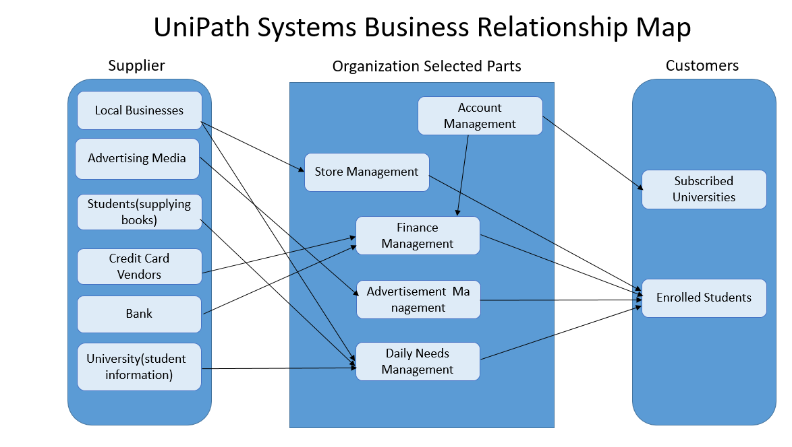**BRM Diagram-**

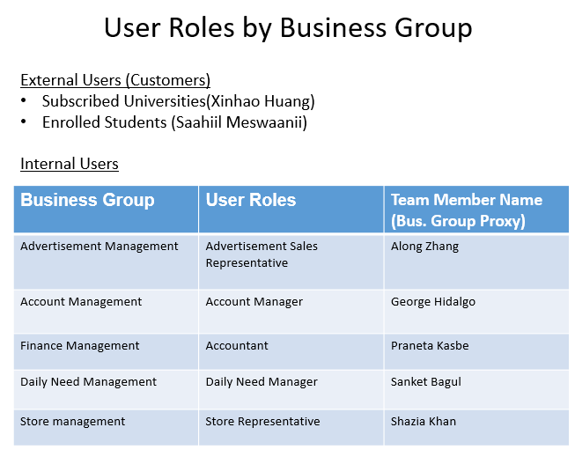

# **Business Requirements – ALL**

This application will serve as a portal for various services. Those services include buying and selling textbooks, getting daily supplies from local businesses and having access to a campus map. UniPath will be structured as a web application that will be financed through partnerships with universities and taking a commission fee through the transactions from the local businesses.

## 4.1 Details of Business Requirements

* + 1. **Account Management Department - George**
       1. Ability to log in
       2. Ability to record income
       3. Ability to record expenses
       4. Ability to create and track invoices
       5. Ability to manage inventory
       6. Ability to process merchandise payments
    2. **Advertisement Management Department - Along** 
       1. Ability to display ads
       2. Ability to view user browsing history within the website only
       3. Ability to keep ads up to date
    3. **Daily Need Management Department - Sanket**
       1. Ability to log in.
       2. Ability to send students information.
       3. Ability to students to sell/buy books hassle-free.
       4. Ability to students to sell/buy their used stuff.
       5. Ability to local stores to receive orders.
       6. Ability to local stores to deliver orders or make a pick-up facility.
       7. Ability to local stores to update the order status.
       8. Ability to send confirmation that the order was delivered.
       9. Ability to users that all services run efficiently.
    4. **Store Management Department - Shazia**
       1. Ability to log in
       2. Ability to add the product name
       3. Ability to upload the product image
       4. Ability to send confirmation that order is in progress.
       5. Ability to send confirmation that the order is ready for delivery
       6. Ability to send the tracking number when order is shipped
       7. Ability to send confirmation that the order was delivered
       8. Ability to check how much sales were made.
    5. **Finance Management Department - Praneta**
       1. Ability to process the plan subscription payments
       2. Ability to verify payment form (i.e. check, credit)
       3. Ability to process retail merchandise payments
       4. Ability to issue refunds
       5. Ability to monitor day-to-day transactions
       6. Ability to monitor financial reporting and analysis
    6. **Subscribed Universities - Xinhao**
       1. Ability to deploy the application on website
       2. Ability to restore the password/user ID details
       3. Ability to stop using the services
       4. Ability to provide a map of the campus
       5. Ability to gain positive testimonies from students
    7. **Enrolled Students - Saahiil**
       1. Ability to modify the account information
       2. Ability to restore the password.
       3. Ability to sign in to (sign out from) already created account
       4. Ability to create post for used products.
       5. Ability to view posts by other students.
       6. Ability to contact seller.
       7. Ability to leave the review of seller.
       8. Ability to add/remove items to/from the cart.
       9. Ability to cancel the order before it is prepared for pickup
       10. Ability to view the order history
       11. Ability to enter/modify the payment information
       12. Ability to submit the form to customer support
       13. Ability to read the resolution of the opened ticket with customer support team
       14. Ability to make product favorite
       15. Ability to view the list of favorite products
       16. Ability to leave the reviews
       17. Ability to rate the products
       18. Ability to view map of campus.
       19. Ability to favorite locations.
       20. Ability to get consolidated information about loans.
       21. Ability to view checklist of documents required.

# **Non-Functional Requirements – All discuss**

|  |  |
| --- | --- |
| **Category** | **Requirements** |
| **Usability** | The application GUI will provide a user-friendly intuitive design with all the features clearly displayed for the user |
| **Usability** | The application navigation will be self-explanatory by clear and concise descriptions and names of each section, as well as features will be clear by proper location and naming |
| **Usability** | The application should be easy to navigate, and users should be able to immediately access any significant functionality that they may need within a few clicks, ideally in one click |
| **Performance** | The application will be supported on different operating systems and browsers, and should not impact the user’s system capabilities |
| **Performance** | The application will be available 24/7 without any interruptions, and regular maintenance will be scheduled to support the application |
| **Performance** | The application will support the concurrency where the users will be able to simultaneously browse the app, login, make payments, shop the products |
| **Performance** | The application will have a short response time to all requests and all the features should be available and not impacted by latency |
| **Security** | The application will be using the automated daily & weekly audits to detect the vulnerabilities. |
| **Security** | The application will use HTTPS protocols for any data exchanges, enforced TLS for all the email communications, and other encryptions that will be maintained on the server |
| **Database** | The application will be using RDBMS |
| **External System** | The application will be able to interface with the external data feeds from and to payment merchants, ad agencies |

# **External Data Feeds – Praneta**

* 1. **Payment System**

Enables the customers to pay for the plan subscriptions and authenticating the transactions.

Enables the customers to receive refunds in case there is an issue while processing the payments.

Enable secure transactions.

Saving the card details.

Purchased supplies final price matches the sum of all single item price.?

* 1. **Supply Stores**

Enables users to buy necessities.

Can order your supplies needed for daily use

Cancel the orders before they are prepared for pickup.

Order information matches with user account information.

* 1. **Advertisement Media Portals**

Advertisements will be displayed on the website to generate revenue.

The advertisements will be updated accordingly.

Remove the advertisements.

Ads systematically feed while user entering website.

* 1. **Map System**

User allows location access.

Maps provide a wider view of the locations, and it provides more context of the university.

Maps will guide the user where to go and with the help of GPS it will track the current location of the users.

* 1. **GPS System**
  + GPS will help to determine the user's source location and will navigate to reach the destination.
  + Outline of building generates as user enter location of where to go.
  + It will help to monitor user movement and geographical location to suggest further directions.

# **Business Risks - George**

Our application will be used to target university students. As students first visit campus, they could get lost or confused about where to go. However, our application will not only help the new students but also the students who are currently at the university with a Buy/Sell feature, this would give the students a space to sell their textbooks and items that they will no longer need to other students who may need it. To make this transaction user-friendly we care creating a safe space in our application to make this experience easy for students to browse what others are selling and have the opportunity to contact them and purchase. Apart from students selling their items on the application there will also be a section for students to buy necessities that we provide for everyday living.

For the technical side of the application, it will need to be analyzed in case of any bugs and the system not working properly. Due to selling products there will be constant monitoring to ensure that the product is up to date and still available. Also, there will be a need to be ready for any kind of cyber-attack as there will be transactions happening on the application, our user's privacy and security could be at risk. Before officially launching the application there will be a beta program so several users can try it out, giving our development team the opportunity to fix the bugs in the system to create a better experience on the day of the launch.